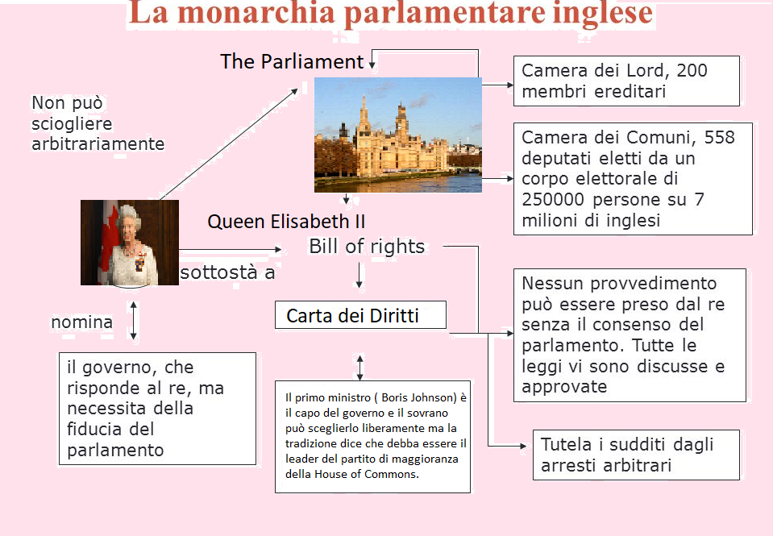
QUESTIONS
- How is composed the Parliament?

- How many members have each Houses?

- Who does appoint the government?

- Who is the head of Government ?

- Who is the head of United Kingdom?

- Who does make the bills (proposte di legge) and then the laws?

- Who is Boris Johnson?

- How are the members of House of Lords elected?

- How are the members of House of Commons elected?

- What’s the seat of Parliament?

