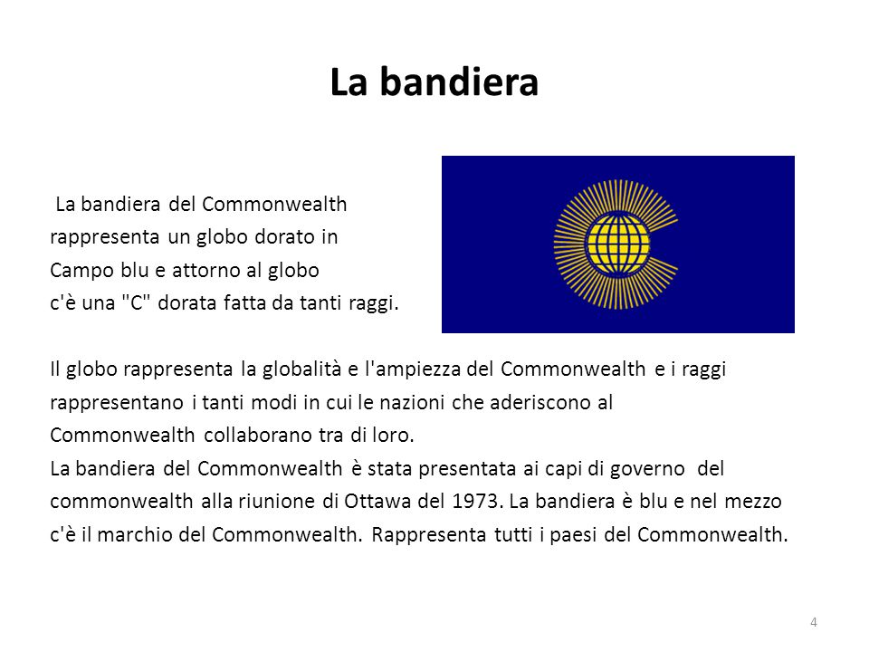
QUESTIONS:
- Why do you think did British Empire need an organization of countries?
- When was it founded, the Commonwealth?
- What’s the name of Commonwealth before 1946?
- How many countries were there in the Commonwealth at the beginning?
- What’s their names?
- And now how many countries are there ?
- When did Australia and New Zeland join the Commonwealth of Nations?
- The Commonwealth Countries are they all independent?
- Where is the headquarters of Commonwealth?
10)Who is the Commonwealth Secretary-General chosen from?
https://www.youtube.com/watch?time_continue=14&v=MndfbY5OaXk&feature=emb_logo

