Nome Classe Data
SCHEDA DVD 3.3

SCHEDA DVD 3.3 CINEMA AND THEATRE IN LONDON
Before watching
VOLUME 3
z1 Match the term on the left with the definition on the right.
- matinée a. a theatre performance
- play b. the first viewing of a new film
- stage c. a show or film with lots of suspense
- ticket booth d. a performance in the morning
- première e. the place where the actors stand
- thriller f. a show with lots of music
- musical g. a place where you can buy tickets for shows

1. .............. 2. .............. 3. .............. 4. .............. 5. .............. 6. .............. 7. ..............
z2 Prepare the questions below and then conduct a brief survey with three classmates.
Ask them:
- if they have ever been to the theatre;
- if yes, what plays they have seen;
- how often they go to the cinema;
- the name of the last film they saw at the cinema;
- what they thought of the film.

While watching
Questa pagina può essere fotocopiata esclusivamente per uso didattico. © Loescher Editore – Torino
z3 Watch the video and number these things in the order you see them.
  - the Priscilla musical
  - cinemas in Leicester Square
  - the Haymarket theatre
  - the We will rock you musical
  - The Mousetrap play

discount ticket booths
  - the park in Leicester Square

1. .............. 2. .............. 3. .............. 4. .............. 5. .............. 6. .............. 7. ..............

486

VOLUME 3 SCHEDA DVD 3.3
SCHEDA DVD 3.3 CINEMA AND THEATRE IN LONDON
z4 Watch and decide if the sentences are Right (R) or Wrong (W).

 | R | W
1. Leicester Square’s in the West End of London. | y | y
2. There are only a few discount ticket booths. | y | y
3. The “discounted” tickets are not always cheap. | y | y
4. You can see films in 3D at Leicester Square. | y | y
5. The 39 Steps is a thriller. | y | y
6. It is usually difficult to get tickets for theatre performances. | y | y
7. The Mousetrap is a very recent show. | y | y
8. Cinema and theatre tickets are cheaper for the matinées. | y | y
9. The matinées are always before midday. | y | y
10. The Royal Haymarket is a historic theatre. | y | y
11. Priscilla is set in England. | y | y
After watching
z
- You’re going to London for a weekend in the next few weeks. Look at the shows currently on in London at:
www.coventgardenlife.com/theatre/theatre.asp
In groups of four decide which show you’d like to go and see and when.
Questa pagina può essere fotocopiata esclusivamente per uso didattico. © Loescher Editore – Torino
Then write an e-mail to the theatre asking about:
- the availability of seats for your chosen day;
- ticket prices;
- how to book.
z

- For more on the history of the Royal Haymarket go to: www.trh.co.uk/history_ page1.php

- Read more about the musical Priscilla: www.priscillathemusical.com/
z
Write an e-mail to a friend describing the show and asking if he / she is interested in going to see it.

487

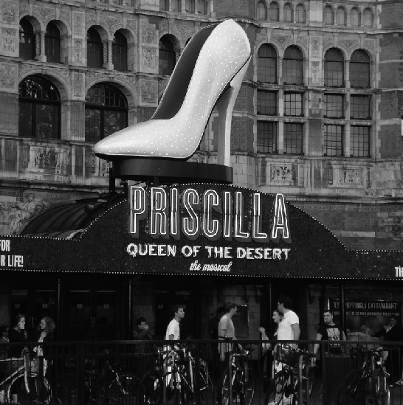
Stalls and Dress Circle: £60, £39.75* Grand Circle: £45, £25**
Balcony: £25, £20
Priscilla
PERFORMANCE TIMES
7.30pm Monday to Saturday evenings 2.30pm Thursday and Saturday matinées
TICKET PRICES
Until 26th September 2009
Monday to Thursday evenings and Thursday matinées
Stalls and Dress Circle: £59.25, £39.75* Grand Circle: £44.75, £24.75** Balcony: £24.75, £19.25
Friday evenings and both Saturday performances
Stalls and Dress Circle: £64.25, £44.75* Grand Circle: £44.75, £24.75**
Balcony: £24.75, £19.25
Prices from 28th September 2009 to 22nd May 2010
Monday to Thursday evenings and Thursday matinées Friday evenings and both Saturday performances
Stalls and Dress Circle: £65, £45* Grand Circle: £45, £25** Balcony: £25, £20
RUNNING TIME
Priscilla runs 2hrs 40mins (including a 20-minute interval)
SCHEDA DVD 3.3
SCHEDA DVD 3.3 CINEMA AND THEATRE IN LONDON
z8 Read the theatre information for Priscilla and answer the questions.
VOLUME 3

* at times, certain production elements may be partially obscured
** some restricted view
All tickets include 75p contribution to theatre restoration. Booking and transaction fees may apply.

1. What’s the most expensive ticket price? ..........................................................................................................................................
Questa pagina può essere fotocopiata esclusivamente per uso didattico. © Loescher Editore – Torino
2. Where do I have to sit if I want the cheapest ticket? .....................................................................................................
3. Is there a performance on Wednesday at 2.30pm? .............................................................................................................
4. When do the prices increase? ......................................................................................................................................................................

5. In which part of the theatre may I have some problems seeing the performance?
............................................................................................................................................................................................................................................................
6. How long is the performance? ...................................................................................................................................................................
7. What does the ticket price include? ....................................................................................................................................................

488

