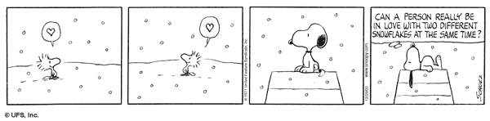

MODAL VERBS: STRUCTURE & USE

What are modal verbs?

- Can
- Could
They are Auxiliary verbs that provide additional and specific meaning to the main verb of the sentence
- May
- Might
- Must
- Shall
- Should
- Ought to
- Will
- Would

How do we use modals?

S M
Subject
V
Verb

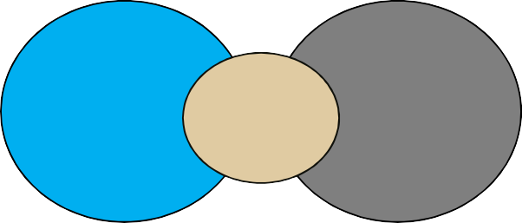

Example: Mary could play the piano

They do not accept conjugation They do not need other auxiliary verbs

Form

There is no “s” in singular
There is no “do / does” in the question There is no “don’t / doesn’t” in the negative

  He can ski He cans ski or He can skis
  Would you like to come with me?

Do you would like to come with me?
  They can’t be serious They don’t can be serious

Form

Modal verbs do not have infinitives or –ing forms

to can / caning to must /musting

Modal verbs are followed by an infinitive without to

She must study (strong obligation)
We should have gone the other way (recommendation) He could play football in his youth (ability in the past)

Form

Modal verbs do not have all the tenses

Modal verbs use other verbs to complete the tenses
Can is completed with be able to Must is completed with have to

They can play the piano They will be able to play the piano in the future You must come early You had to come early yesterday

What do they express?

They can have more than one meaning depending on the situations

- Single Conce pt Mo d a l: they have o ne meaning
- . D ouble Concept Moda l: they have two meanings
- Modals in past: They are used to express a situation in the past

Categories

Single concept Modals | Double Concept Modals | Modals in Past
Will | May | Would have
Might | Must | Could have
Should | Would | Might have
Ought to | Shall | Should have
Had better | Could | May have
 | Can | Must have

Single Concept Modal

Modal | Concept | Examples
Will | Future | Joe will travel to NY next week
Might | Small probability | I might move to Canada some day
Should | Recommendation | You should go to the doctor
Ought to | Formal recommendation | We ought to know about first aids
Had better | Warning ( avvertimento) | I had better study or I will fail the test

Double Concept Modal

Modal | Concept | Examples
May (1) | Permission | May I come in?
May (2) | Good probability | We may visit Mexico this summer
Must (1) | Responsibility | Everyone must pay taxes
Must (2) | Assumption | She didn’t arrive. She must be sick
Would (1) | Past (used to) | When I was young, I would play soccer
Would (2) | Present unreal | I would buy the car but I can’t afford it

Double Concept Modal

Modal | Concept | Examples
Shall (1) | Educated expression Offer | Excuse me, I shall go now Shall I clean it?
Shall (2) | Contractual obligation | The company shall pay on January 1st
Could (1) | Unreal Ability | I could go if I had time
Could (2) | Past Ability | She could play the piano (but she can’t anymore)
Can (1) | Present Ability | We can speak English
Can (2) | Permission | Can I have a candy?

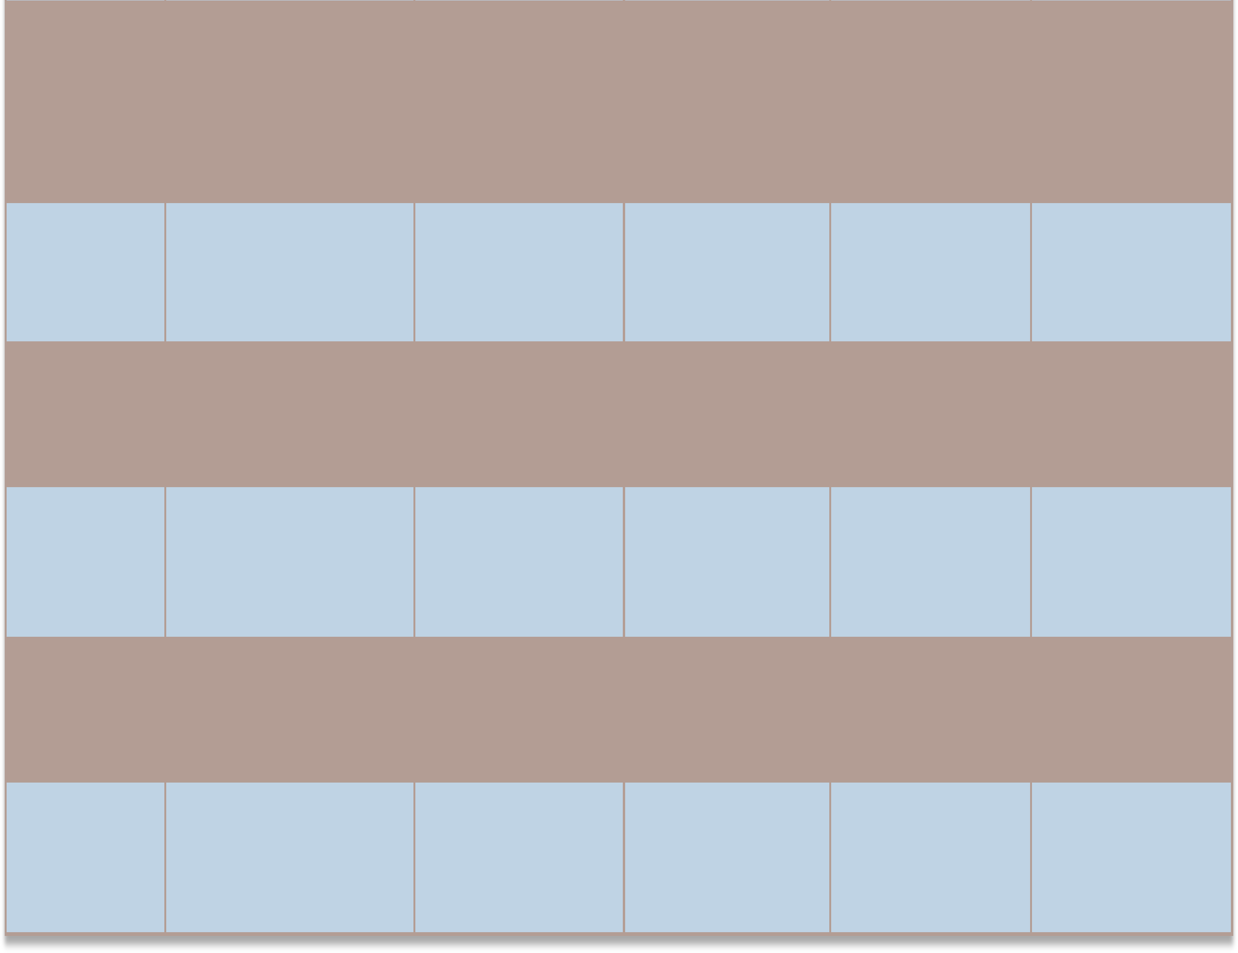

 | PROBABILITY/ POSSIBILITY | ABILITY | PERMISSION | OBLIGATION/ ADVICE | OFFERS
CAN |  | I can play the piano | Can I go out tonight?
CAN’T | She can’t be his mum. She ‘s too young | I can’t speak German | Can I borrow the car? No, I can’t.
MIGHT | It might rain tomorrow
COULD | It could rain tomorrow | I could already read when I was two | Could I see your passport please, sir?
MAY | It may rain tomoroww |  | May I leave the table?
MUST | She must be his sister because they look alike. |  |  | You must leave before the clock strikes twelve.
HAVE TO |  |  |  | I have to study tonight.
SHALL |  |  |  | You shall pay on Tuesday | Shall I help you?
SHOULD / |  |  |  | You should see it.
OUGHT TO |  |  |  | It’s excellent.
HAD BETTER |  |  |  | You had better sleep more.
WOULD |  |  |  |  | Would you like a drink?

Modals in the Past

  They are modals referred to actions that happened in the past

It must have been a difficult decision
They should have invited her to their wedding

MODAL + HAVE + verb in past participle

MODAL PERFECT USE S E XAMPL E S
MUST HAVE + P.P. Logical conclusion on a past event Peter has arrived late. He must
have been in a traffic jam

MAY / MIGHT HAVE + P.P. Deduction on a past event Joe may / might have taken the
wrong train.

COULD HAVE + P.P. Possibility to do something, gone unfulfilled
You could have played better

COULDN’T HAVE + P.P. Certainty that something couldn’t have
happened

WOULD HAVE + P.P. Desire to do something, but impossibility to do it for external causes
He couldn’t have passed because you hadn’t studied enough
I would have visited you, but I forgot your address

SHOULD /
OUGHT TO HAVE + P.P.
Lament on something that should have been done
You should / ought to have warned me earlier

SHOULDN’T HAVE + P.P. Critique on something that shouldn’t
have happened
He shouldn’t have told them

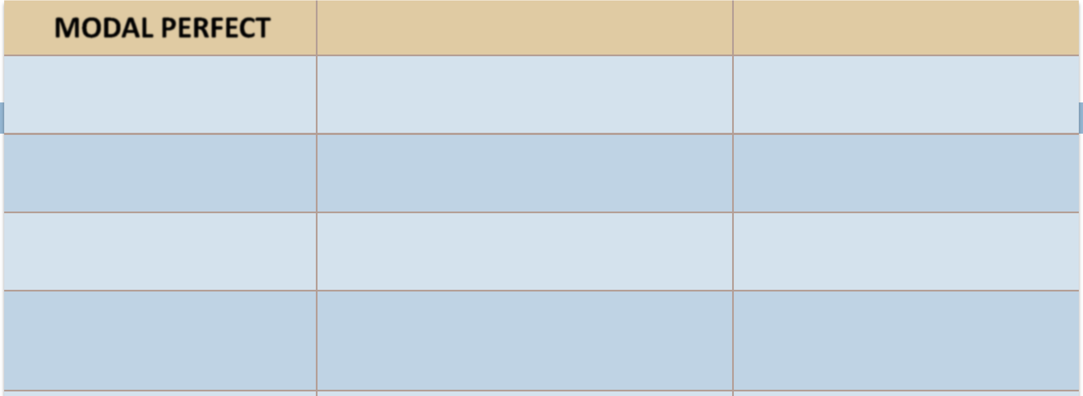

NE EDN’T HAVE + P.P. Somthing that wasn’t necessary doing You needn’t have bought it .

Modals-like verbs:

A few verbs which often serve as modals too.
They need to be conjugated.

Modal Concept Example
Like to Enjoy I like to watch TV

Want to Desire John wants to buy a car

Need to Necessity We really needed to talk to you Have to Obligation Susan had to pay the rent
Have got to Have to I’ve got to go now

Look forward to Future plan I look forward to seeing you again

Practise

- My son be home by now. Where can he be?

  - Have to b. would should d. could
c.

- I think your thumb is broken. You go to the emergency room.

  - Might b. could ought to d. can
c.

- If you are interested in losing weight, you try this new diet.
  - Could b. mustn’t c. don’t have to d. had to
- John’s fallen down the stairs! I call an ambulance!
  - Will b. might c. may d. ought to
- You come too early. We won’t leave until 9 o’clock.
  - Has to b. must c. needn’t d. can’t

Practise

- Children be accompanied by an adult at the zoo.

  - Ought to must c. would d. mustn’t
b.

- You talk during tests. It’s forbidden!

  - don’t have to mustn’t c. couldn’t d. ought to
b.

- I can feel the heat. We be near the fire.
  - Can b. would c. must d. have to
- They hear him because he was whispering.
  - Wouldn’t b. mustn’t c. shouldn’t d. couldn’t
- You’ve never heard of Britney Spears? You be serious!
  - Must b. had to c. can’t d. shouldn’t

Practise

- you like to have dinner with me tonight?

  - Could b. may c. should would
d.

- You let him hear about the party tomorrow. It’s a surprise!
a. mustn’t
b. wouldn’t
c. couldn’t
d. can
13. I speak to the Chief Councellor, please?
a. Must
b. May
c. Would
d. Need
14. He has arrived late. He missed the bus
a. Must have
b. Should have
c. Could have
d. must

More practise

  Re-write the following sentences using modals so that they have the same meaning.
- I suggest that you get a good lawyer! You shoul_d get a lawyer
_
_
_
_
_
___
___
__
- A university degree isn’t necessary for that job.
You needn’t have a university _degree for that job don’t have to have a university…
_
__
_
_
_
_
_
__
_
_
_
_
_
_
__
_
__
__
_
__
_
_
_
- Perhaps my father will pick you up.
My father may /_mig_ht_pick_you_up
_
_
_
_
_
_
_
_
__
_
_
_
_
- 4. Eating is forbidden in class! You mus_tn’t eat in class
_
_
_
_
_
__
_
_
_
_
_
_
_

More practise

  Re-write the following sentences using modals so that they have the same meaning.
- Look at his dirty clothes! I’m sure he is a poor person.
He mus_t be a poor person
_
_
_
_
_
_
_
_
_
_
_
_
_
_
- I don’t believe that the legend of Hercules is true because there are many contradictions.
The legend of Hercules can’t be true
_
_
_
_
__
_
_
_

Use your imagination

  Think about these situations and create a sentence using modals.
- We are going to Paris for a weekend. (Make suggestions about things to do)
- We start school in September. (Talk about necessity)
- Margaret is a very talented sportswoman. (Talk about ability)
- You have just won the lottery! (Talk about possibility)
- Peter has got a headache and a congested nose. (Give him some advice)
- You want to borrow your uncle’s Mercedes Benz. (Ask for permission politely)

