Nome Classe Data

SCHEDA DVD 1.7 LONDON SIGHTSEEING
Before watching

1 Rispondi alle seguenti domande.
- What’s the name of this square?
...................................................................................................................

- What’s the name of the man on top of the big column? ...................................................................

- What’s the name of this bridge?
...................................................................................................................
- Abbina le seguenti parole inglesi con il loro equivalente italiano.
  - wheel a. ruota
  - capsule b. andare in bici
  - tower c. gradini
  - fire d. ponte
  - landmark e. centrale elettrica
  - cycle f. duomo
  - keep order g. morire
  - die h. capsula
  - bridge i. torre
  - power station j. posto famoso
  - dome k. incendio
  - steps l. mantenere l’ordine

1. a.... | 2. | .............. | 3. .............. 4. | ..............
5. .......... | .... 6. | .............. | 7. .............. 8. | ..............
9. .............. 10. .............. 11. .............. 12. ..............

While watching
- Metti i seguenti elementi nell’ordine in cui li vedi nel video.

c. Miftftennium Wheeft d. British Museum
e. the park f. Trafaftgar Square
g. Buckingham Paftace
b. Houses of Parftiament
a. Dockftands

1. c....
2. .............. 3. .............. 4. ..............

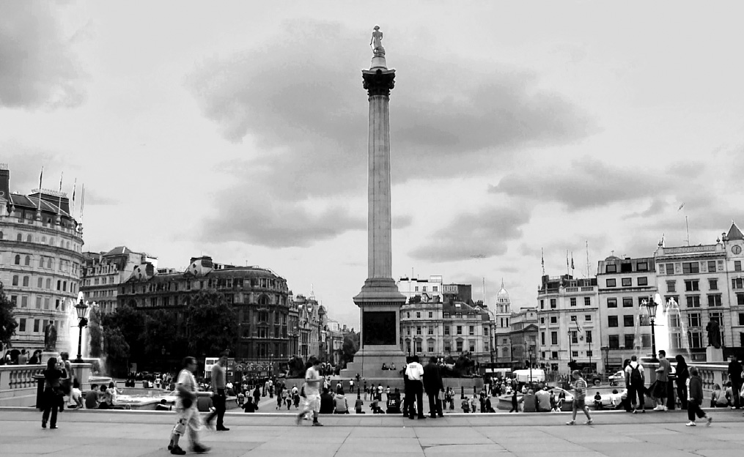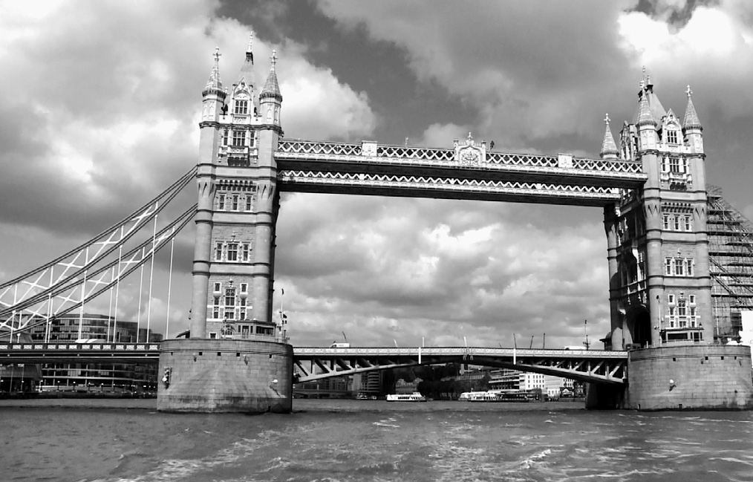5. .............. 6. .............. 7. ..............

SCHEDA DVD LONDON SIGHTSEEING

Scegli l’alternativa corretta.

- On the London Eye there are  a. 42 capsules. | b. 52 capsules. | c. 32 capsules.
- Big Ben is  a. a station. | b. a clock. | c. a Parliament building.
- Another name for the Palace of Westminster is
  - the London Eye. b. Houses of Parliament. c. Millennium House.
- Which of these things can’t you do in Regent’s Park?
  - Walk around. b. Play sports. c. Cycle.
- The Millennium Bridge opened
  - on June 10th 2000. b. on July 12th 2000. c. on June 12th 2000.
- The Millennium Bridge connects
  - St. Paul’s and the Tate Modern. b. St. Paul’s and Westminster.
c. the Tate Modern and the British Museum.
- There are steps up to the Gallery in St. Paul’s.
a. 530 b. 250 c. 150
- When Tower Bridge opens, traffic stops for
  - 5 minutes. b. 15 minutes. c. 50 minutes.
- In the Docklands area you can find
  - only offices. b. apartments and offices. c. only apartments.

After watching
- Tramite Internet trova altri luoghi da visitare a Londra. Organizza un viaggio di tre giorni per te e i tuoi amici.

- Vai sul sito: www.tfl.gov.uk/tickets/faresandtickets/1067.aspx
Trova le seguenti informazioni.
  - What is an Oyster card?
  - What benefits are there for young people?
  - How can I get an Oyster Card?

461

