Nome Classe Data

SCHEDA DVD THE ROYAL FAMILY
Before watching
Completa l’albero genealogico della Famiglia Reale inglese.

............................1 ............................2

............................3

Diana
............................4

Mark Phillips
............................5
............................6

............................7 ............................8

Camilla Timothy Laurence

William
Henry
............................9
............................ 10
............................ 11
............................ 12
............................ 13

............................ 14 ............................ 15

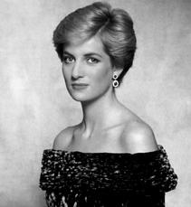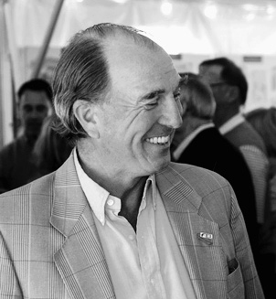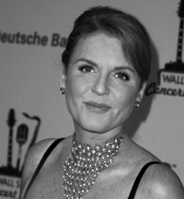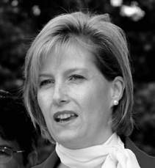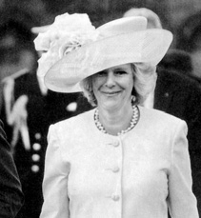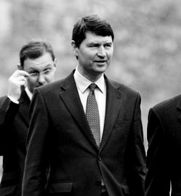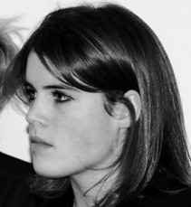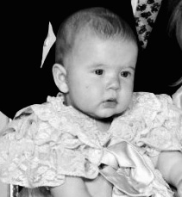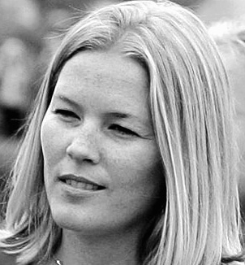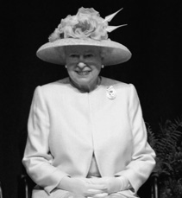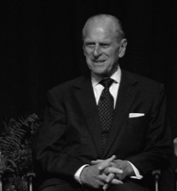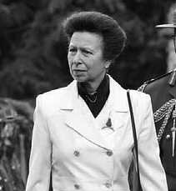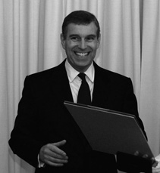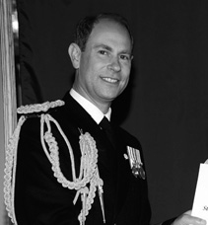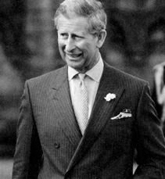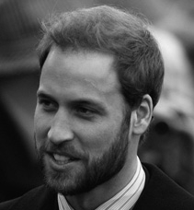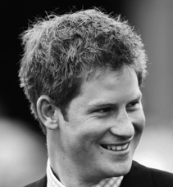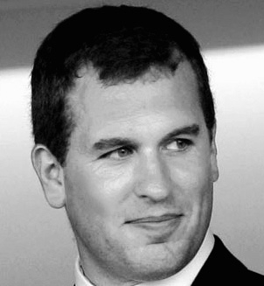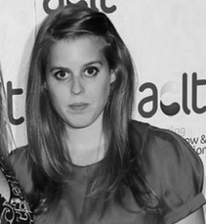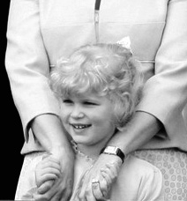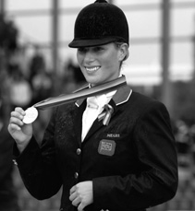

- Elizabeth’s the Queen of England.
- Her husband’s Philip, the Duke of York.
- They’ve got three sons and a daughter.
- The Queen’s daughter’s name’s Princess Anne.
- The Queen’s sons names are Prince Charles, Andrew and Edward.
- Princess Anne’s got a son, Peter, and a daughter, Zara, from her first marriage.
- Peter’s married to Autumn Kelly.
- Prince Andrew is divorced from Sarah, Duchess of York.
- They have got two daughters, Beatrice and Eugenie.
- Prince Edward’s wife’s Sophie.
- Prince Edward and Sophie have got a son, Severn, and a daughter, Louise.

SCHEDA DVD 1.3 THE ROYAL FAMILY

  - Che cosa sai della Famiglia Reale inglese? Decidi se le frasi sono Right (R) o Wrong (W), poi verifica la correttezza delle tue risposte con un compagno.

 | R | W
1. Prince Philip comes from Greece. | y | y
2. Prince William is a qualified helicopter pilot. | y | y
3. The Queen has German origins. | y | y
4. The Queen likes horses. | y | y
5. The Queen officially opens Parliament in October. | y | y
6. She speaks to the Prime Minister in private every week. | y | y
7. The Queen has 10 corgis (small dogs). | y | y
8. The successor to the Queen is Princess Anne. | y | y

  - Abbina le parole inglesi con la loro traduzione italiana.
    - guard a. pelliccia
    - statue b. governare
    - monarch c. forze armate
    - regiment d. reggimento
    - fur e. conte
    - carriage f. carrozza
    - earl g. regnare
    - armed forces h. guardia
    - reign i. statua
    - rule j. parata aerea
    - flyover k. monarca

.....
1. | h | 2. | .............. | 3. .............. | 4. | ..............
5. | .............. | 6. | .............. | 7. .............. | 8. | ..............

9. .............. 10. .............. 11. ..............

While watching
  - Guarda il video e poni i seguenti elementi nell’ordine in cui vengono mostrati.
z
- planes flying over
- the Horse Guards
- Buckingham Palace
- a statue of Queen Victoria
- the Foot guards
- Camilla and Prince Edward
- Pall Mall
- the Royal family on the balcony

1. .c.... | 2. | .............. | 3. .............. | 4. | ..............
5. ........... | ... 6. | .............. | 7. .............. | 8. | ..............

451

SCHEDA DVD THE ROYAL FAMILY
Guarda il video un’altra volta e decidi se le frasi sono Right (R) o Wrong (W).

1. Buckingham Palace is the Queen’s home. | R  y | W  y
2. The Queen’s Guards come from four different regiments. | y | y
3. The Changing of the Guard is in the afternoon. | y | y
4. The bearskin hat is 55.7cm tall. | y | y
5. Another name for the bearskin is a “billy”. | y | y
6. The Queen’s official birthday is on April 21st. | y | y
7. The Queen doesn’t vote. | y | y
8. The Queen’s surname is Winter. | y | y
- The Queen is Head of the Army but not Head of the Church.  - There are 31 members of the Royal Family. | y  y | y  y
11. You can visit Buckingham Palace in December. | y | y
12. The blue white and red smoke represents the British flag. | y | y

